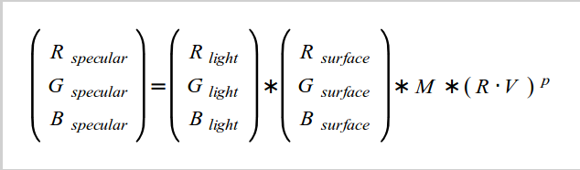

**Per-Fragment lighting**

**'M'** here is the specular intensity of the material. Material which does not have any specular property (e.g. wood) would have a specular intensity of zero which make it zero

Shinier stuff such as metal can have increasingly higher levels of specular intensity.

P is the "specular power' or the 'shininess factor'

**The three different kinds of light objects are**

**http://docs.worldviz.com/vizard/Light_basics.htm**

**1. Directional**

**2. Point**

**3. Spot**

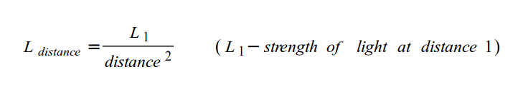**Point Light**

Fading effect of point light is usually called 'attenuation'

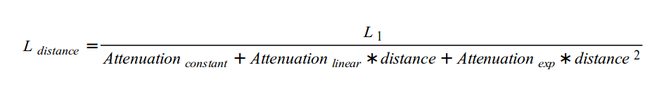

**Spot Light**

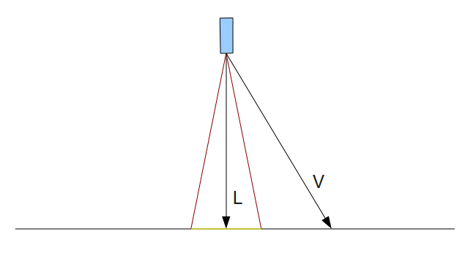

**L: light direction**

**V: light origin to the pixel**

if pixel in the cone, we want it to receive light